**M.S.P.VELAYUTHA NADAR LAKSHMITHAIAMMAL**

**POLYTECHNIC COLLEGE**

**PAVOORCHATRAM – 627808**

**DEPARTMENT OF COMPUTER ENGINEERING**



**PROJECT TITLE: HEALTH CONNECT**

**Project report: 2023-2024**

**Under the Guidance of,**

Mr. Mani Raj Sir

**Submitted by**

**Team Members:**

1. Charles J
2. Ravi Arun
3. Marri Vijayan
4. Muhammed Afsal

**Index:**

|  |  |
| --- | --- |
| **S.NO** | **Content** |
| 1. | Abstract |
| 2. | Overview |
| 3. | Software Required |
| 4. | Existing system and Proposed system |
| 4. | Key Features |
| 5. | Mission and Impacts |
| 6. | Database Tables |
| 7 | Conclusion |

**Health Connect: Intelligent Healthcare Recommendation System for Personalized Patient Care**

**Project Abstract:**

"Health Connect" is an innovative healthcare recommendation system that enhances patient care through personalized suggestions based on individual health records, preferences, and location. Using advanced data analytics and machine learning, the platform recommends doctors and hospitals tailored to a patient's needs and proximity. Privacy and security are prioritized with robust encryption, and user feedback continuously refines the recommendation algorithms. "Health Connect" strives to optimize accessibility and convenience, fostering a dynamic and responsive healthcare network for improved patient outcomes and experiences.

**Introduction:**

"Health Connect" is an innovative healthcare recommendation system designed to enhance patient care by leveraging patient data and location information. The platform employs advanced data analytics and machine learning algorithms to analyse individual health records, considering medical history, preferences, and treatment requirements.

Key features include a personalized doctor and hospital recommendation engine that takes into account the patient's health needs and geographical location. By combining these factors, the system ensures that patients receive tailored suggestions for healthcare providers and facilities, optimizing accessibility and convenience.

The project places a strong emphasis on data privacy and security, implementing robust encryption and authentication protocols to safeguard sensitive patient information. Additionally, the platform integrates user feedback to continuously improve and refine its recommendation algorithms, ensuring a dynamic and responsive healthcare network.

"Health Connect" serves as a valuable tool in promoting efficient and patient-centric healthcare, offering a seamless connection between patients and healthcare providers. By harnessing the power of data-driven recommendations, this system aims to improve patient outcomes and overall healthcare experiences.

**Software Used :**

* Visual Studio Code 2023
* PyCharm
* SQL software
* Google Sheets for data Management for development

**Proposed system :**

* We are creating this web application to easy the work of the patient to get the knowledge about the Doctors and Hospitals.
* Here We suggest the hospitals through the Map and its location based on the patient requirement.
* We can store the patient details and the details can be accessible form anytime and anywhere through our web application and we will provide a robust security for the patient details.
* The patient details can be shared by using QR code technology on our application.
* We suggest the nearby Doctors by analysing the patient data which has been given by the patient and by their location.

**Existing system :**

Name of the existing software system: Healthgrades

**About Healthgrades :**

Healthgrades is an online healthcare platform designed to empower individuals in making informed decisions about their healthcare providers and facilities in the United States. The platform offers comprehensive profiles of healthcare professionals, including physicians and specialists, presenting crucial information such as education, certifications, and specialties. Patient reviews and ratings contribute valuable insights into the quality of care and overall patient satisfaction. Healthgrades extends its functionality to include detailed profiles of hospitals, providing users with data on ratings, services, and patient safety scores. The platform also offers information on specific medical procedures and conditions, aiding users in understanding treatment outcomes and success rates. Healthgrades facilitates the appointment booking process with some providers and serves as a resource for educational health content. Recognizing excellence, the platform presents annual awards to hospitals and providers achieving high performance in quality and patient safety metrics. With its diverse functionality, Healthgrades serves as a multifaceted tool for users seeking reliable information and reviews to guide their healthcare choices.

**Difference in our software applications are :**

* **Personalized Suggestions**: The system utilizes individual health records, preferences, and location data to offer personalized recommendations, ensuring that patients receive healthcare options tailored to their specific needs.
* **Data Analytics and Machine Learning**: Advanced data analytics and machine learning algorithms are employed to analyze vast amounts of healthcare data, enabling the platform to provide intelligent and data-driven recommendations.
* **Optimized Accessibility and Convenience**: "Health Connect" aims to optimize accessibility and convenience by recommending healthcare providers based on proximity. This can improve the ease with which patients can access necessary medical care.
* **Privacy and Security**: The abstract emphasizes the priority placed on privacy and security, indicating that robust encryption measures are in place to protect sensitive health information. This commitment to security helps build trust among users.
* **Continuous Refinement**: User feedback is incorporated into the recommendation algorithms, leading to continuous refinement and improvement. This iterative process ensures that the system evolves and becomes more effective over time.
* **Dynamic and Responsive Healthcare Network**: The platform is designed to foster a dynamic and responsive healthcare network. This suggests that the system can adapt to changes in healthcare provider availability, quality, and other factors, ensuring a flexible and responsive user experience.
* **Improved Patient Outcomes and Experiences**: The overarching goal of "Health Connect" is to enhance patient care, indicating a focus on improved patient outcomes and experiences. By facilitating personalized and convenient healthcare options, the platform aims to contribute to overall positive health outcomes for users.

In summary, "Health Connect" seeks to bring about advantages such as personalization, data-driven recommendations, accessibility, security, continuous improvement, a responsive network, and ultimately, improved patient care and experiences.

**Key Features :**

**1. Personalized Recommendation Engine:**

The cornerstone of "Health Connect" is its personalized doctor and hospital recommendation engine. This engine factors in the patient's unique health needs alongside their geographical location. This innovative approach ensures that patients receive tailored suggestions for healthcare providers and facilities, ultimately optimizing accessibility and convenience.

**2. Hospital Location Mapping with Google Maps Integration:**

"Health Connect" enhances the patient experience by integrating Google Maps API to dynamically display hospital locations based on patient requirements. Users can easily view and navigate to recommended healthcare facilities directly from the web application. This feature provides a visual representation of nearby hospitals, clinics, or medical centres, offering convenience and ease of access for patients seeking in-person care.

**3. Data Privacy and Security:**

"Health Connect" places a paramount emphasis on data privacy and security. Robust encryption and authentication protocols are implemented to safeguard sensitive patient information. This commitment to security underscores the platform's dedication to maintaining the confidentiality and integrity of patient data.

**4. Proximity-Based Doctor Recommendations:**

"Health Connect" introduces a groundbreaking feature that suggests healthcare providers based on the patient's requirements and the proximity of doctors to the patient's location. Leveraging geolocation data, the platform intelligently recommends doctors who are nearby, facilitating prompt access to medical care. This real-time, location-aware recommendation system enhances the platform's commitment to optimizing accessibility and ensuring that patients can easily connect with healthcare professionals in their vicinity.

**5. Continuous Improvement:**

The platform doesn't stop at its initial capabilities. "Health Connect" integrates user feedback as a dynamic component, ensuring a continuous cycle of improvement and refinement in its recommendation algorithms. This responsiveness to user input contributes to the evolution of a healthcare network that adapts to changing needs and remains at the forefront of technological advancements.

**6. QR Code Generator for Secure Data Sharing:**

"Health Connect" introduces an innovative feature with a QR Code generator for secure data sharing. This functionality enables healthcare providers and authorized individuals to share patient details seamlessly through the web application. The generated barcodes encode patient information securely, facilitating efficient and error-free data transfer while maintaining the platform's commitment to privacy and security.

**Mission and Impact :**

**1. Patient-Centric Healthcare:**

"Health Connect" is committed to revolutionizing healthcare by placing patients at the center of the experience. The platform facilitates a seamless connection between patients and healthcare providers, promoting an efficient, personalized, and responsive approach to medical care. The emphasis on patient-centric healthcare underscores the platform's dedication to enhancing the overall well-being and satisfaction of individuals seeking medical support.

**2. Data-Driven Personalization:**

At the core of "Health Connect" is a robust commitment to data-driven recommendations. Through the integration of advanced analytics and machine learning, the platform aims to improve patient outcomes and elevate the healthcare experience. By leveraging patient data, the system tailors recommendations based on individual medical history, preferences, and the latest medical insights, ensuring a personalized and informed approach to care.

**3. Comprehensive Electronic Health Records (EHR) Management:**

"Health Connect" empowers healthcare providers with a comprehensive Electronic Health Records system. This system centralizes and organizes patient information, facilitating efficient and coordinated care. Adhering to industry standards for interoperability, the platform ensures seamless data exchange, contributing to a unified and holistic view of patient health records across the healthcare ecosystem.

**4. Geographic Accessibility through Google Maps Integration:**

The integration of Google Maps into "Health Connect" takes accessibility to a new level. Patients can visually explore and select healthcare providers based on geographic proximity, enhancing the convenience of choosing and accessing medical services. This feature aligns with the platform's mission to optimize accessibility and convenience, making healthcare more approachable for users.

**5. Continuous Innovation in Healthcare Ecosystem:**

"Health Connect" maintains a commitment to continuous innovation in the healthcare ecosystem. The platform's proactive approach includes features such as Google Maps integration and proximity-based doctor recommendations, demonstrating its dedication to staying at the forefront of technological advancements. By fostering an intuitive and dynamic healthcare environment, "Health Connect" ensures that users benefit from the latest and most effective tools in their healthcare journey.

**6. Timely and Personalized Healthcare with Proximity-Based Doctor Recommendations:**

The introduction of proximity-based doctor recommendations exemplifies "Health Connects" dedication to providing timely and personalized healthcare. By considering both the specific health needs of the patient and the geographic location of healthcare providers, the platform streamlines the process of accessing medical expertise. This feature contributes to the overall mission of making healthcare more accessible, efficient, and tailored to individual need.

**Modules:**

1. Login Page
2. Getting the user details
3. Home page
4. Category selection page
5. Providing the doctors details and the location
6. **Login Page:**
7. **User Authentication:**

* This module handles user authentication, ensuring that only authorized users can access their health connect accounts.

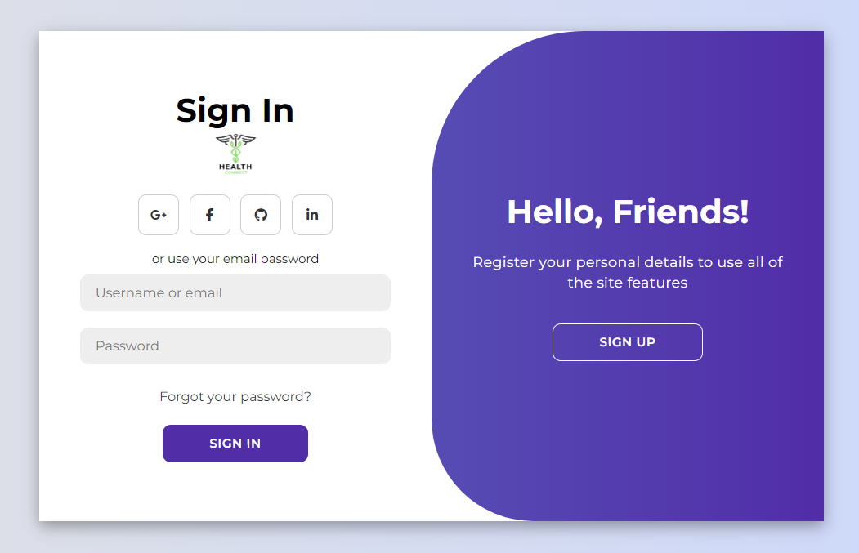

1. **Signup page**

* **New user creation:** This form allows users to create a new account on the website. They will need to provide their name, email address, and create a password.
* **Data Submission:** Signup form data is stored in a MySQL database table with hashed passwords. This includes user details like username (VARCHAR) and email (VARCHAR) for identification, and a hashed password (VARCHAR) for secure access. Additional user information (optional) might also be stored with appropriate data types.

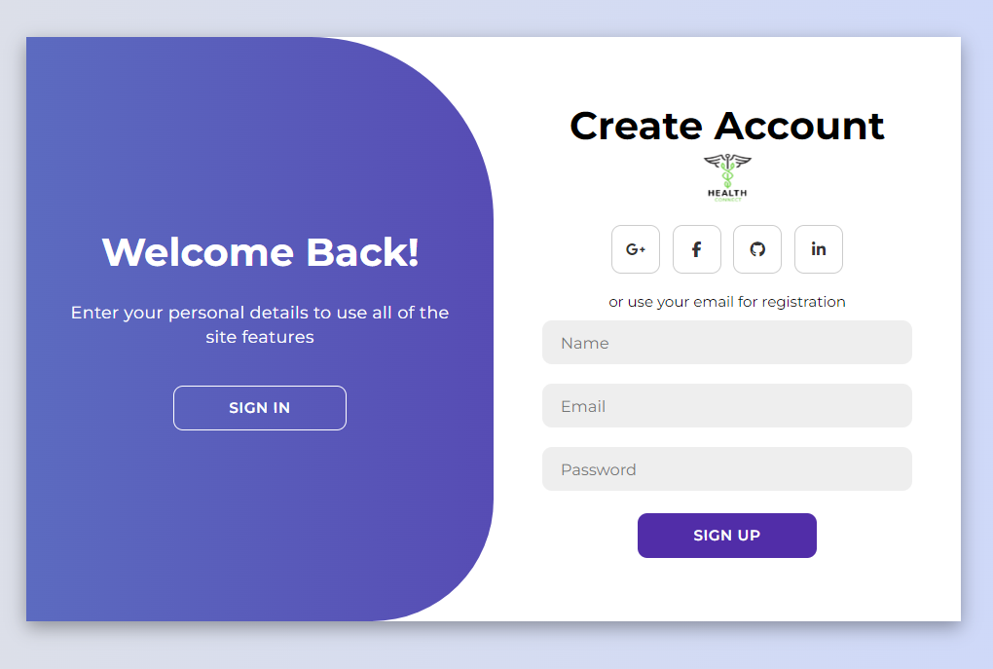

1. **Getting the user details:**

* **User Data Collection:** The form collects health data from the user, including name, blood group, age, gender, any conditions they might have (e.g., cardiovascular diseases), and potentially a profile image.
* **Data Submission:** Once the user fills out the form and clicks "Submit," the data is likely sent to a server-side script for processing.

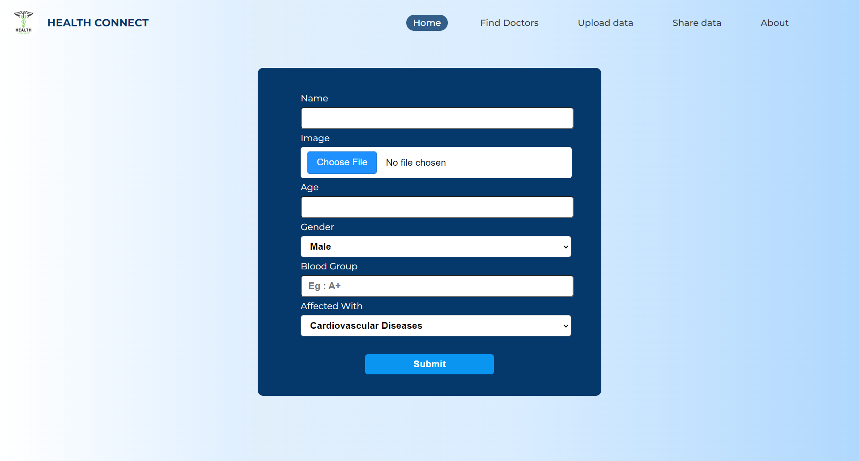

1. **Home page :**

* **Interactive Body Part Selection:**The webpage seems to have an image of a human body divided into sections corresponding to different body parts. Clicking on a specific body part might redirect the user to a webpage that caters to that particular body part.
* **Targeted Content:**Each body part category page would likely provide relevant information about conditions affecting that body part, nearby hospitals and diagnostic centers specializing in that area, and possibly even doctors who specialize in treating conditions related to that body part.

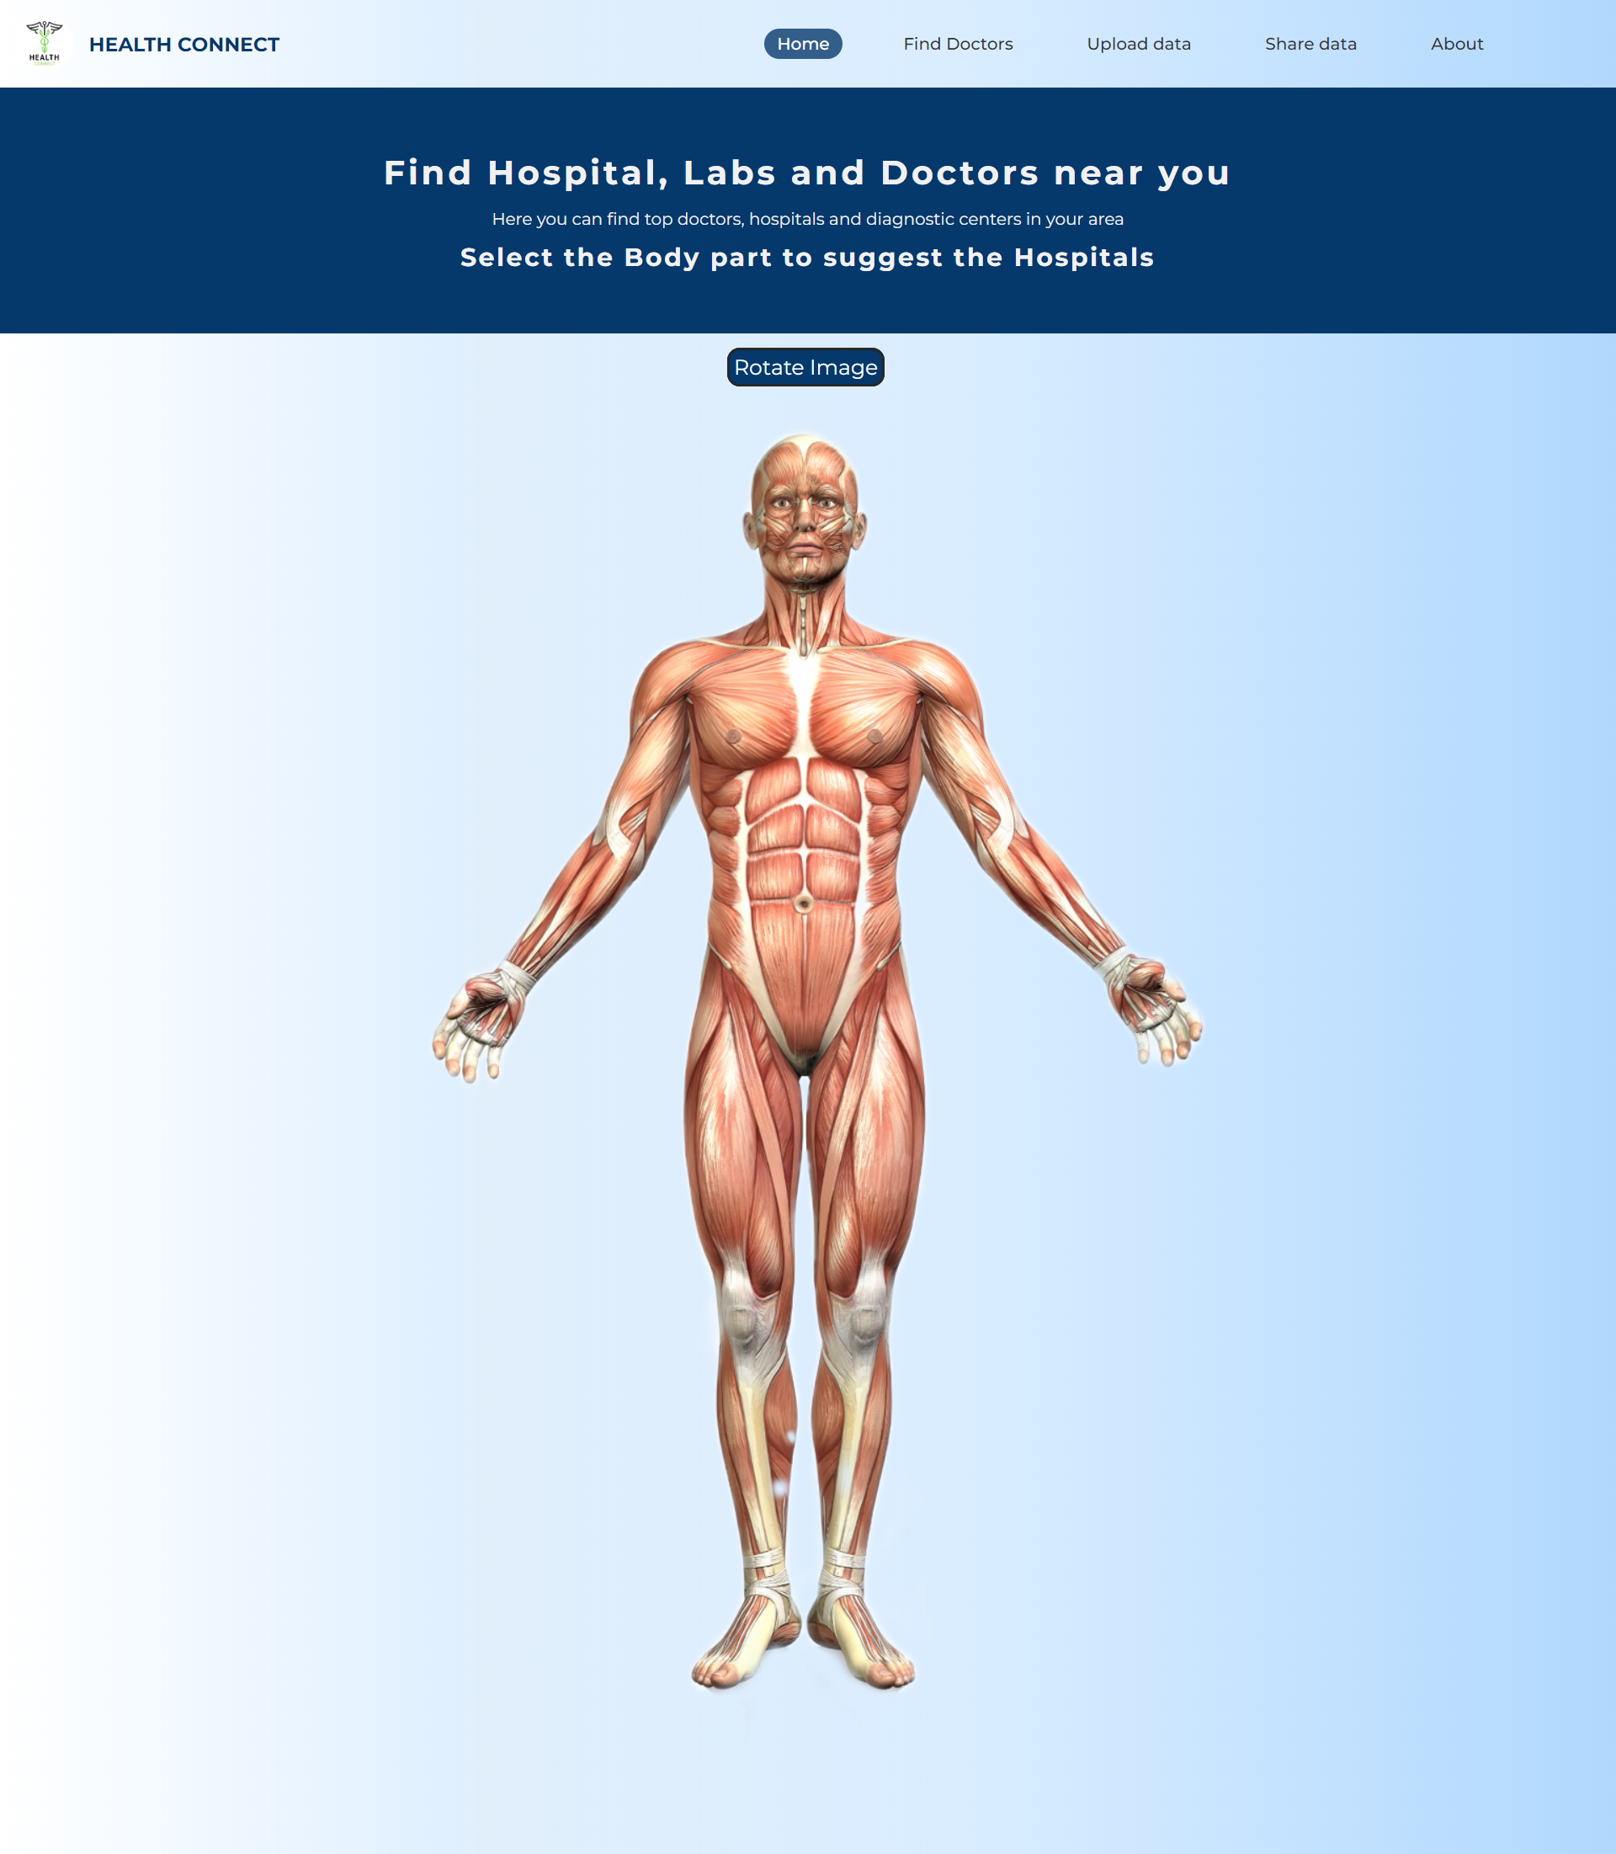

1. **Category selection page:**
   * **Body Part Categories:**The webpage displays a list of body part categories. These categories seem to correspond to different specialties within medicine. For example, there is a category for “Neurologist” (Brain), “Dental” (Teeth), and “ENT” (Ear, Nose, and Throat).
   * **Doctor Listing:**Clicking on a particular body part category might redirect the user to a new webpage that lists doctors who specialize in treating conditions related to that body part.

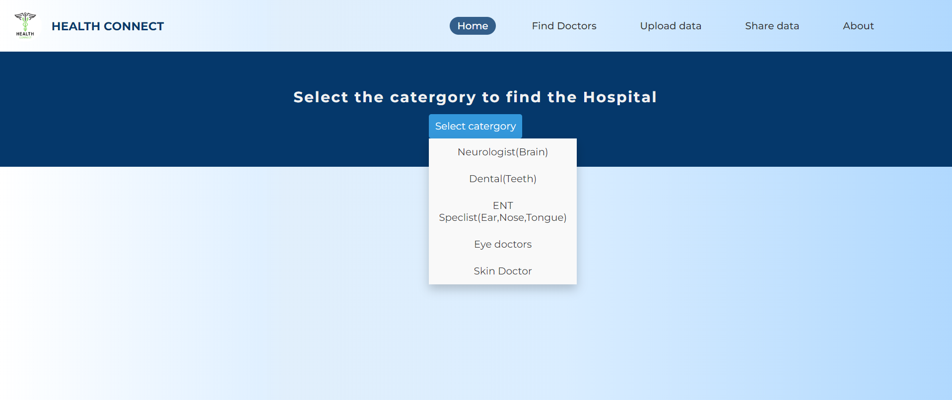

1. **Admin page**

**Doctor Registration:**

* The form allows doctors to register on the Health Connect website.

**Doctor Information:**

* Doctors can enter their details such as name, profile picture, specialization (through a dropdown menu with a pre-defined list of options like General Doctor), district, city, address, hospital name (if applicable), phone number, and availability timings.

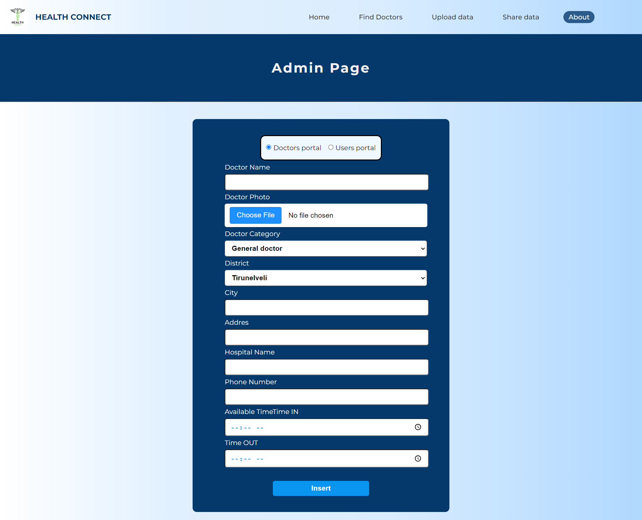

1. **Admin page for user modification**

* **User Authentication**: The page requires users to enter a username and password to log in. This verifies the user's identity before allowing them to access their account information.
* **Login Success:**If the username and password match the information stored in the database, the user is likely redirected to a user modification page where they can view and edit their account details.
* **User Modification:** The user modification page might allow users to change their information such as username, password, email address, or other profile details (depending on the functionalities implemented).

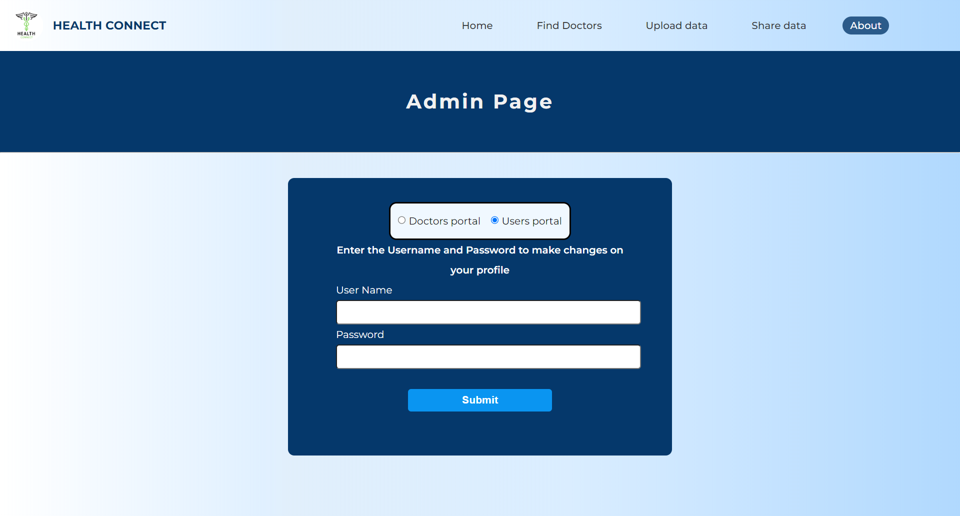

**Database Tables:**

**1. tbl_login(id,username,email,password)**

**2. tbl_doctor_details(id, doc_name, doc_img, doc_img_path, category, district, city, address, hospital_name, phone, time_IN, time_OUT)**

**3. tbl_user_details(id, name, user_img, age, gender, blood_group, affected_with)**

**4. tbl_user_address(id, addr, city, district, state, country)**

**5. tbl_doctor_images(id, doc_pic1, doc_pic2, doc_pic3, doc_pic4, doc_pic5, doc_pic6)**

**6. tbl_user_medicalreport_images(id, rep1, rep2, rep3, rep4, rep5, rep6, rep7, rep8, rep9, rep10)**

**7. tbl_user_medicalbill_images(id, bill1, bill2, bill3, bill4, bill5, bill6, bill7, bill8, bill9, bill10)**

**Table Relations:**

* Every tables can make a relationships with the help of ID filed (Primary key).

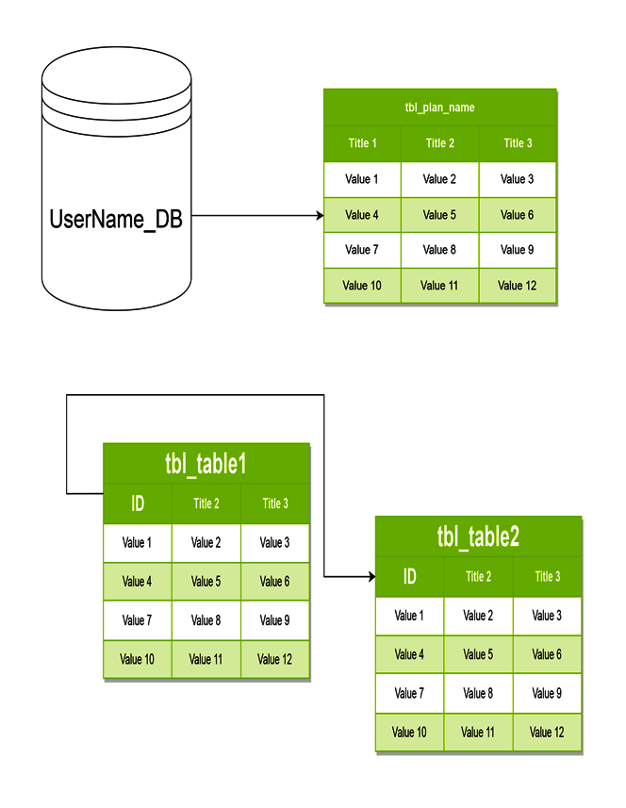

**Conclusion:**

"Health Connect" represents a groundbreaking advancement in healthcare technology, leveraging data analytics and machine learning to revolutionize patient care. By analyzing individual health records and location information, the platform provides personalized recommendations for doctors and hospitals, prioritizing the unique needs and geographical convenience of each patient. The system's dedication to data privacy, continual refinement through user feedback, and its commitment to creating a responsive healthcare network underscore its role as an innovative and patient-centric tool. "Health Connect" not only aims to improve patient outcomes but also strives to redefine the healthcare experience by seamlessly connecting individuals with the most suitable and accessible healthcare providers.